# Introduction

iAttendance serves as a platform which allows professors and students to access the attendance question efficiently. It consists of two main pages, the professor page and the student page. The professor’s page would allow the professor to set an attendance question either by voice recognition or text. It would also allow for the professor to view all the students answer and retrieve the students list who are absent from the class.

Important Links

iAttendance link: <https://keezhongping.github.io/>

Prof Page Password: prof

# iAttendance [Student]

This page allows the student to view and answer the attendance question.

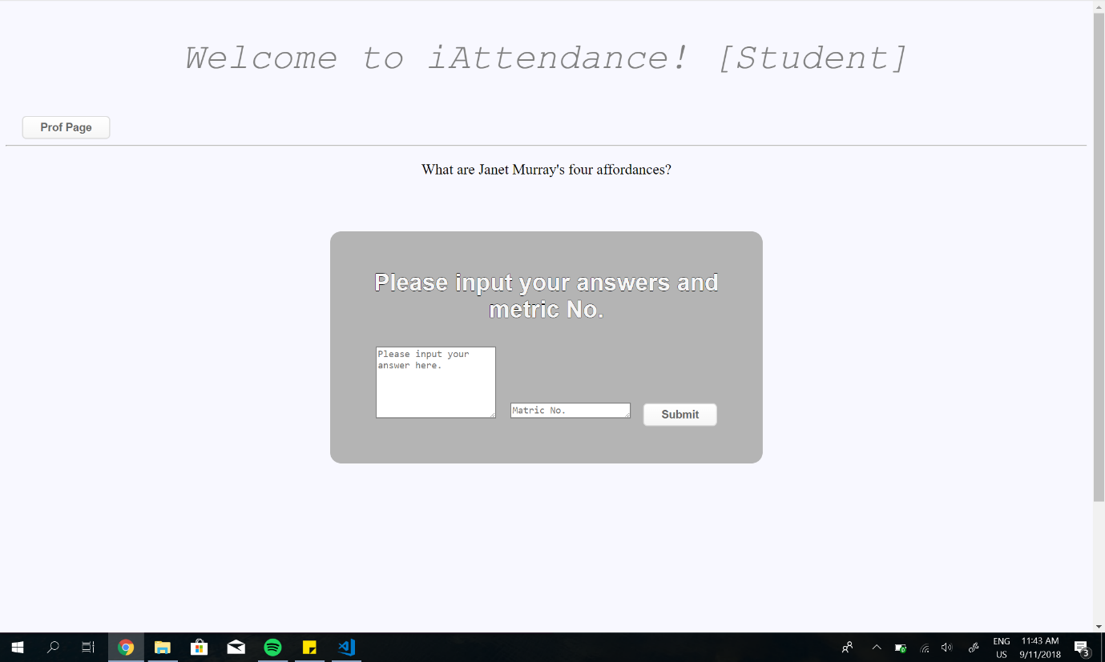

Matric Number Input (Student)

Answers input

Attendance question

Steps of answering attendance question:

1. Enter <https://keezhongping.github.io>
2. Key in answer and Matric number
3. Click submit

Time verification

Students are only allowed to enter their answer from 0800 to 1000 during the class. Any other timing would return an error notification and their response would not be recorded.

Prof Page Button

Clicking on this button would trigger a password request and if the correct password is entered, the user would be navigated to the professor page.

An incorrect password would trigger a notification and user will not be navigated.

# iAttendance [Professor]

This page allows the user to:

* Set an attendance question
* View student’s answers
* View absent students

Set attendance question

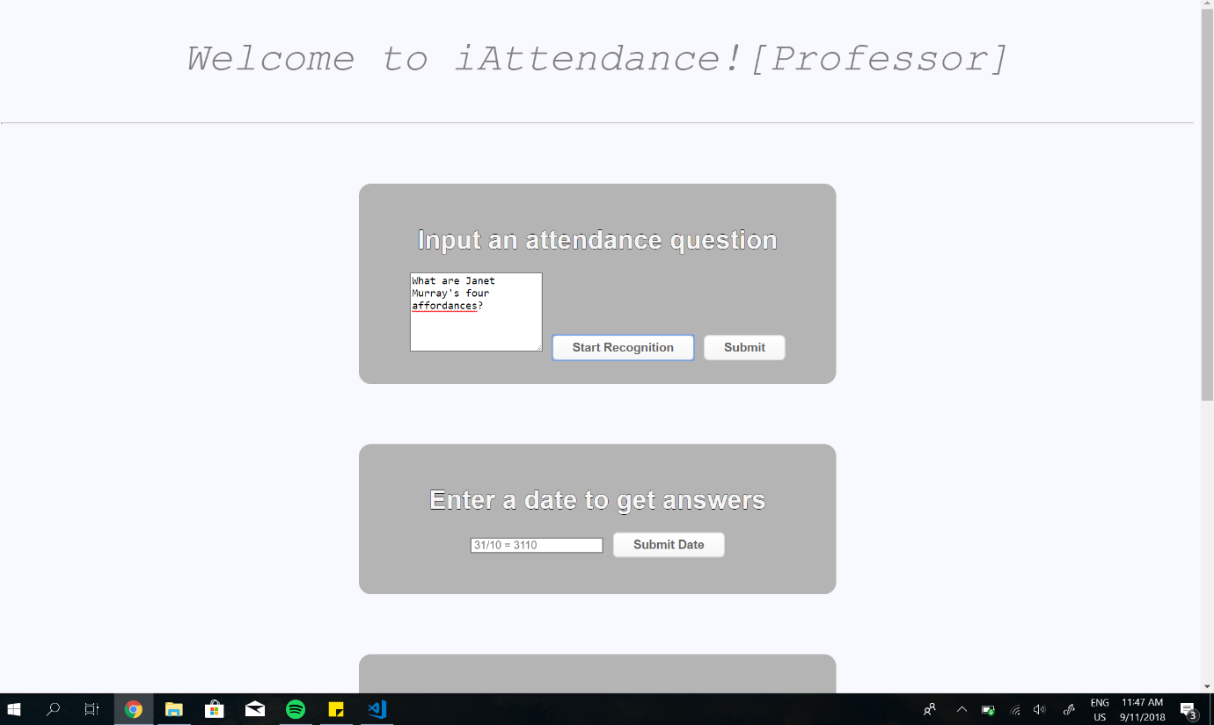

Attendance question box

The Attendance question box can be populated by two ways:

* Voice Recognition
* Text

If the user wishes to use voice recognition, click on “Start Recognition” and a blinking red circle would appear at the tab. Refer to the figure below.



Upon the presence of the red circle, the user can now speak and end with a pause. The speech will then populate the attendance question box. The user will be able to edit the box if needed. Finally the user would click “Submit” and the attendance question will be posted.

For text, user would be able to type into the attendance question box and click “Submit” after.

View Students Answer

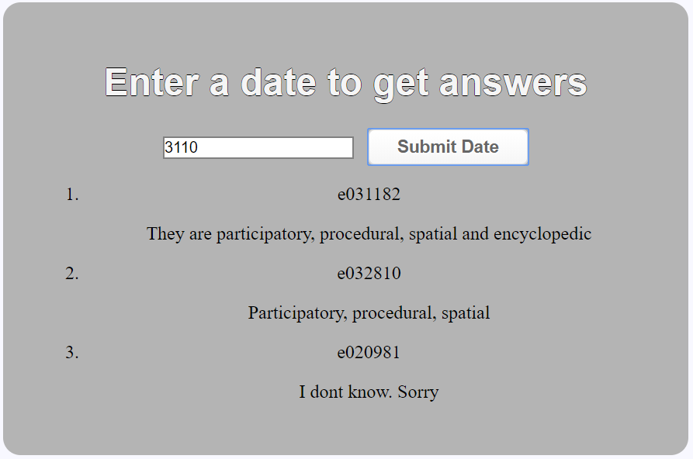

This would be a simple view of all the student’s answer in the following order:

1. [Matric Number]

[Student’s input]

The date entered follows the following format: “ddmm”.

Example:

31/10/2018 would be inputted as “3110”.

25/01/2018 would be inputted as “”2501”.

View Absent Students

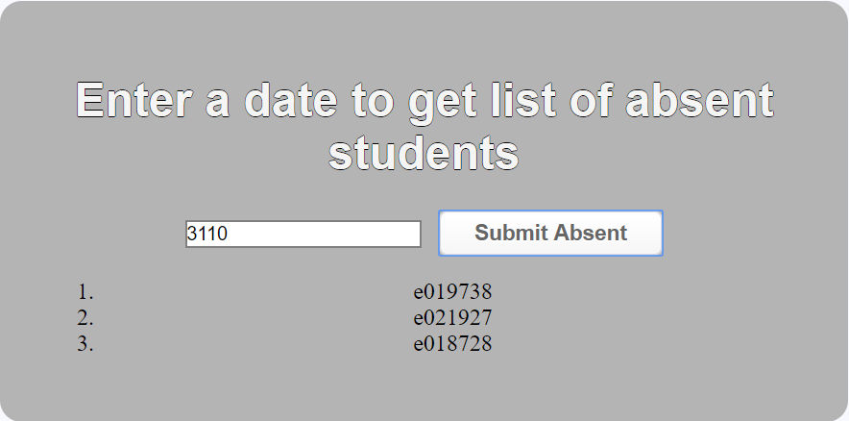

This would be a simple view of all the student’s answer in the following order:

1. [Matric Number]

The date entered follows the following format: “ddmm”.

Example:

31/10/2018 would be inputted as “3110”.

25/01/2018 would be inputted as “”2501”.

The search algorithm is as follows:

1. Loop through class list in database (Refer to database section)
2. For each student, check with the answer pool, if student has an answer, skip. Else send to absent list.

# Database Structure

Link to database

<https://get1033-ce07e.firebaseio.com/>

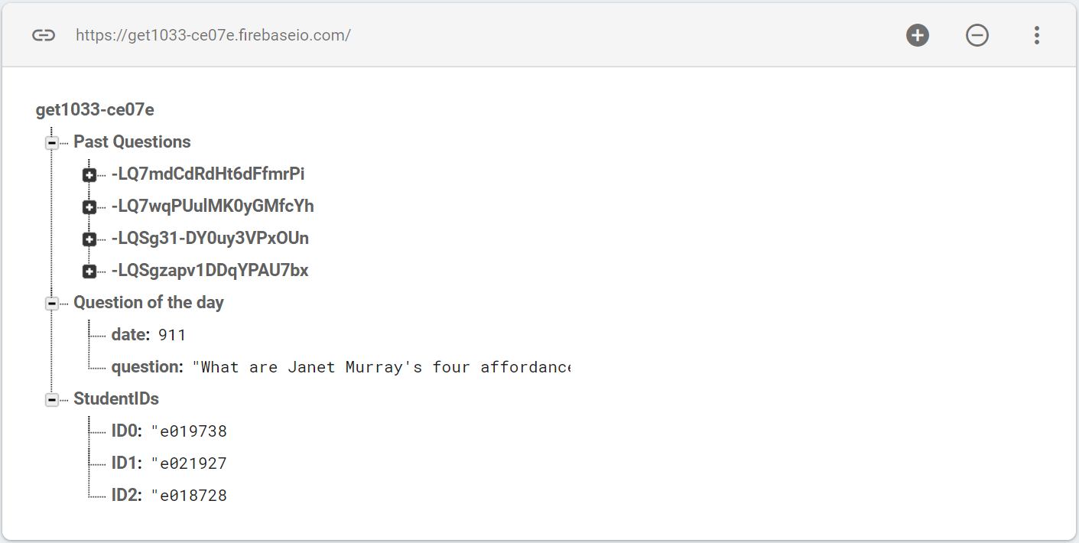

The database consist of 4 main sections:

* Past Questions
* Question of the day
* StudentIDs

Past Questions

Every student input will be logged here. Each input will be represented by a random key and the internal structure is as follows:

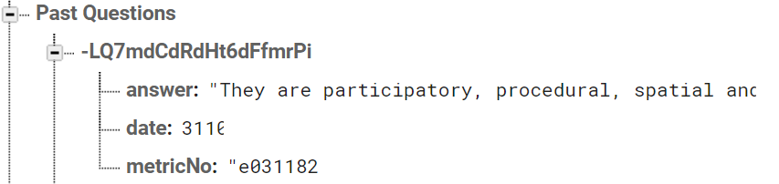

“answer” would capture the answer keyed by the student.

“date” would be automatically recorded when the student submits his/her answer in the form [ddmm].

“metricNo” would be inputted by the student and used for checking of attendance.

Question of the day

This field would be captured when the professor enters a new attendance question. It would instantly replace the previous question and appear on the student’s page simultaneously.

StudentIDs

Student IDs are a collection of the class metric numbers. This field has to be populated only once by the user before the start of a new semester.